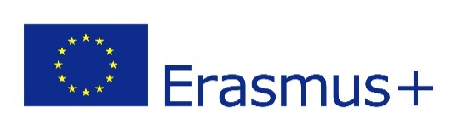
KA2 COOPERATION FOR INNOVATION AND
THE EXCHANGE OF GOOD PRACTICES
October, 2020

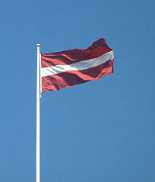
Erasmus+ project “Birds have to fly!”
Collaborative work on
four adventurous stories
Latvia, Jaunjelgavas vidusskola
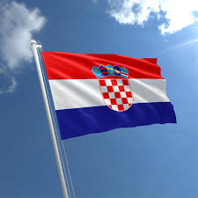

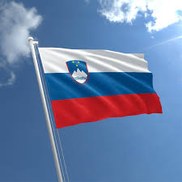
Croatia, Osnovna skola Brsadin

Slovenia, Osnovna skola Franca Lesnika
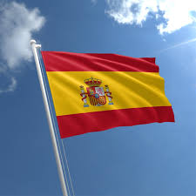

Spain, Colegio Escuelas Pías Santa Engracia

