Birds have to fly!
Ptice moraju letjeti!

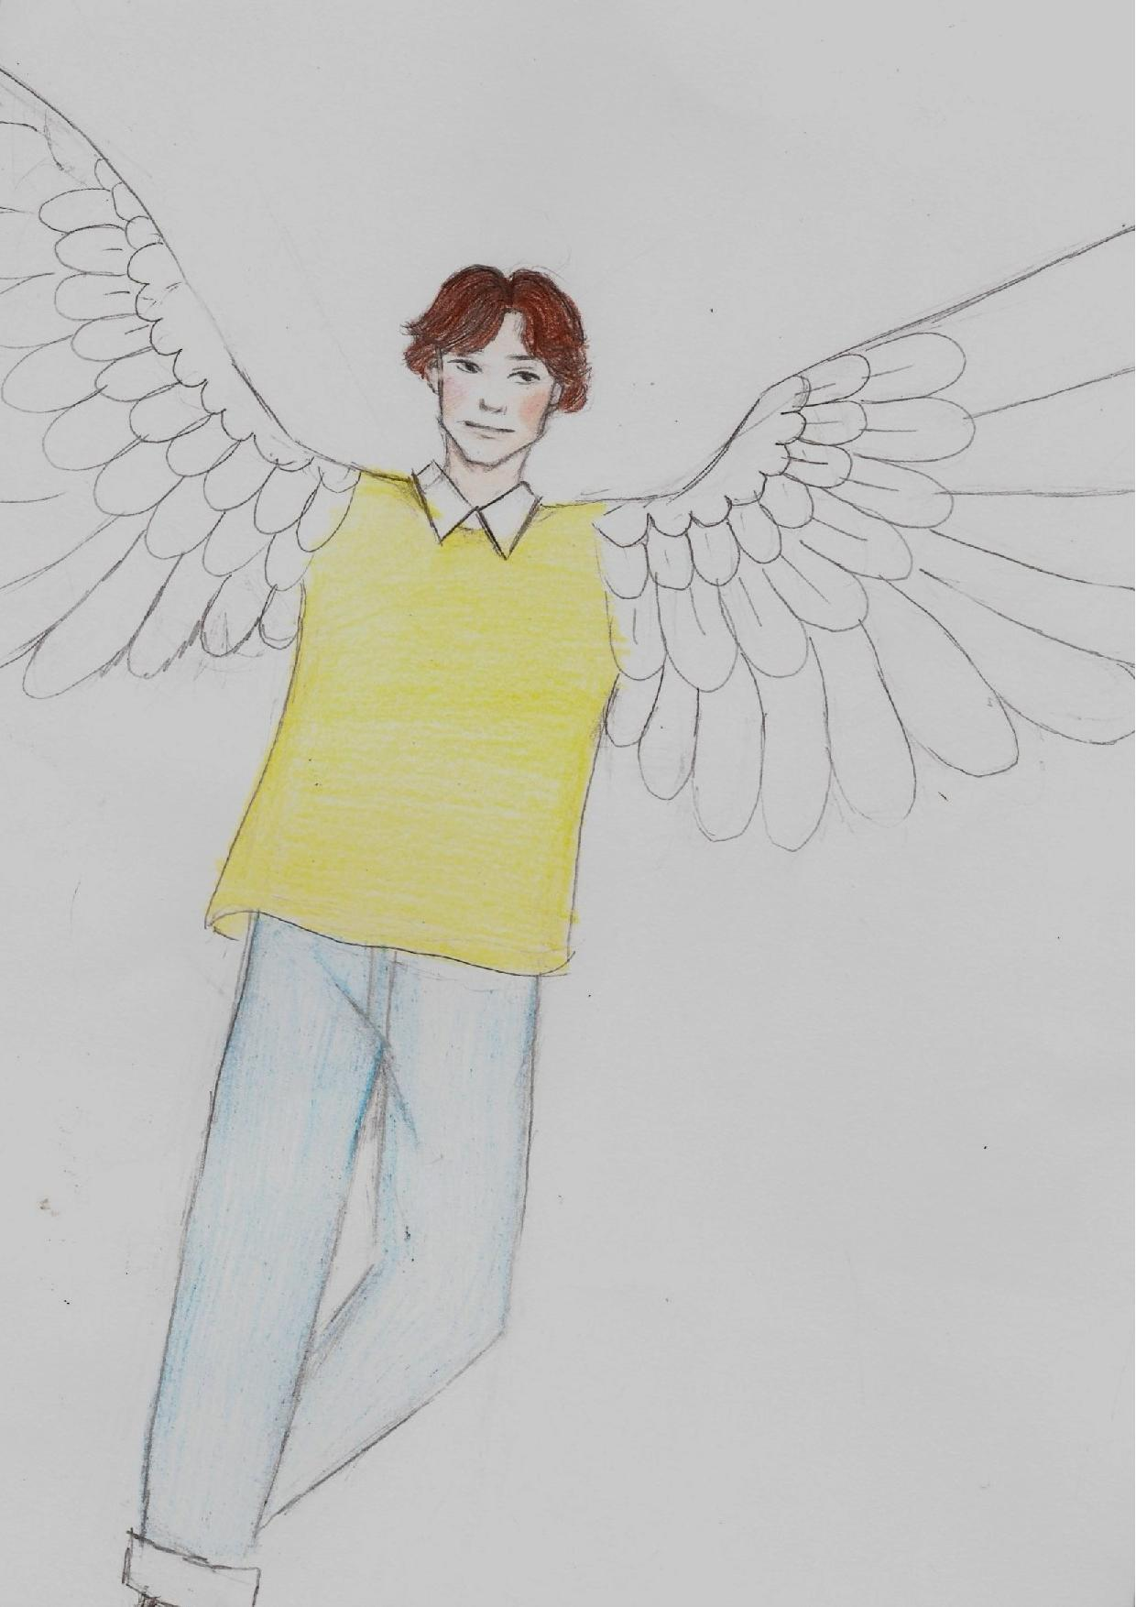
On je drugačiji od drugih, poseban je i svira predivno gitaru. Riječ je o dječaku Zvonku. Zvonko ima trinaest godina, ide u sedmi razred Osnovne škole Marijinih pet listova. Gitaru je počeo svirati u drugom razredu, a sada je pravi majstor sviranja, iako zna da još mora vježbati. Njegov stil odijevanja se razlikuje od drugih. Nosi široke dukserice tamnih boja i šarene traperice. Nosi dioptrijske naočale okruglog oblika, a od dvanaeste godine nosi aparatić za zube. Zbog svog izgleda je predmet izrugivanja na svoj račun. Odlučio je to promijeniti i poletjeti u oblake s drugim pticama u veliko jato sloge i mira.

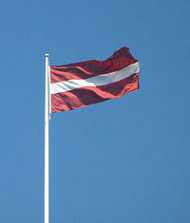
He is different from others, he is special, and he plays the guitar beautifully. He is a boy called Zvonko. Zvonko is thirteen years old; he is in the seventh grade of the Elementary School of Marija's five sheets. He started playing guitar in second grade and is now a true master of playing, even though he knows he still has to practice. His style of clothing is different from others. He is wearing wide dark sweatshirts and colourful jeans. He wears round prescription glasses, and since the age of twelve, he has been wearing braces. Because of his appearance, he is the subject of ridicule at his own expense. He decided to change that and fly into the clouds with the other birds into a large flock of harmony and peace.
Zvonko zināja, ka vecāki neļaus viņam vienam pašam doties lielajā plašajā pasaulē. Tāpēc, nevienam par to nesakot ne vārda, viņš aizbēga no mājām, lai piepildītu savu sapni apceļot plašo pasauli. Zvonko devās pats, nezinādams kur, līdzi ņemot savu ģitāru. Tā bija ļoti lietaina nakts, un tuvojās vētra. Sava lidojuma laikā Zvonko neko nevarēja redzēt slikto laika apstākļu dēļ. Pēkšņi Zvonko sadūrās ar nezināmu putnu.
Tā izrādījās Dzērve, kas lidoja no Londonas, kur viņai bija koncerts. Dzērve prata spēlēt klavieres un dziedāt. Viņa dodas pasaules koncertturnejā apkārt pasaulei. Dzērve bija ļoti skaista, ar garām kājām un spicu deguntiņu. Dzērve, redzot, ka Zvonko līdz ir ģitāra, sacīja, ka viņa meklē ģitāristu, jo vēlas veidot savu grupu. Un tā viņi kopā devās tālāk uz...

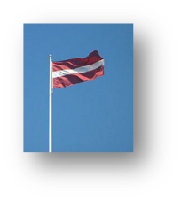
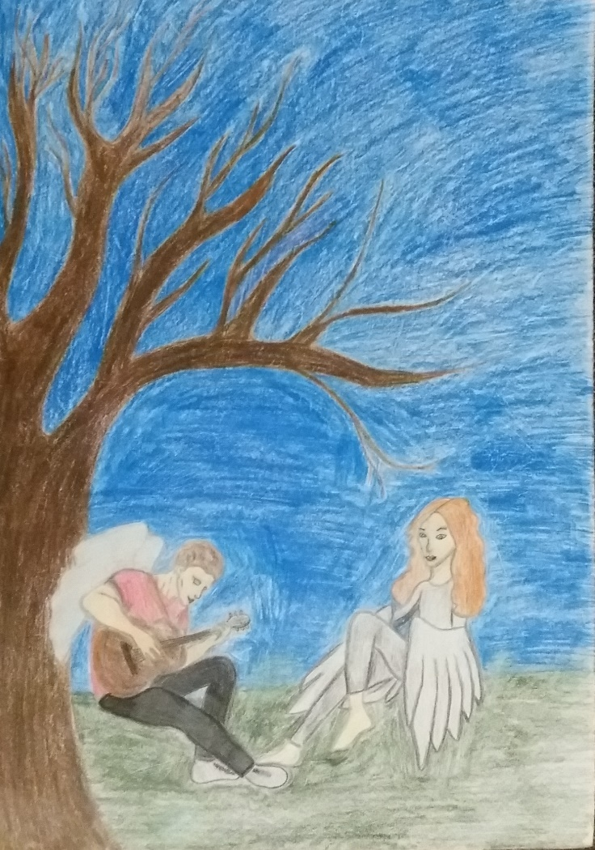
Zvonko knew that his parents would not allow him to go into the big wide world on his own. That's why, without so much as a word to anyone about it, he ran away from home to fulfil his dream of traveling all around the whole world. Without knowing where exactly he was going, Zvonko left by himself taking his guitar with him. That was a very rainy night, and a storm was approaching. During his flight, Zvonko could not see anything due to the bad weather. Suddenly Zvonko collided with an unknown bird.
It turned out to be Crane flying from London, where she had a concert. Crane plays the piano, and she is a singer. She goes around the world on her world-tour. The Crane was very beautiful, had long legs and a pointed nose. The Crane, seeing that Zvonko had a guitar with him, said that she is looking for a guitarist because she wants to form her own band. Therefore, together they went further to...

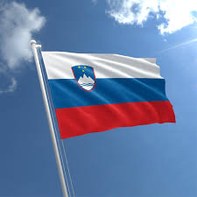
Zato sta skupaj najprej šla do osamljenega ribnika, kjer sta vadila, se opevala in uglasila svoje instrumente. Ko sta že hotela oditi, pa se je iz hiške poleg ribnika zaslišal nenavaden zvok. Iz radovednosti sta pokukala skozi okno hiške. Videla sta 3 barvne papige, 2 nadarjeni raci in 4 goske sopranistke, ki so pele karaoke, medtem ko so se razigrano lovile. Zvonko in Crane sta pogledala drug drugega in se odločila previdno stopiti v hiško. Še preden sta zaprla vrata, so ju ptice opazile. Opevane ptice so se začudeno spogledale, nato pa ju prijazno nagovorile: »Pozdravljena prijatelja! Kaj dogaja? Kaj vaju je prineslo v naše kraje?« Zvonko in Crane sta prijazno in vljudno odgovorila: »Že iz oblakov sva zaslišala vaše prečudovite glasove in neizmeren talent, zato si nisva mogla pomagati in sva kar vstopila naprej. Med letom sva premišljevala, da potrebujeva več članov za uspešno turnejo, zato naju zanima, če bi postali del najinega benda.« Ptice so dolgo premišljevale in se med seboj posvetovale kar trikrat, na koncu pa so le prišle do odločitve …
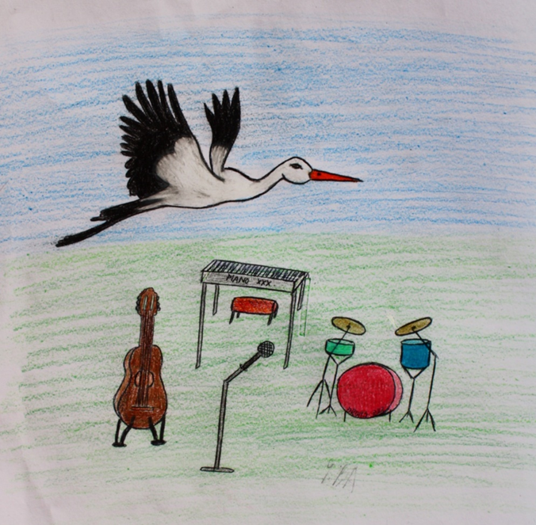
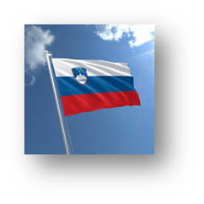

Therefore, together they went further to … a secluded pond where they practiced, sang and tuned their instruments. As they were about to leave, an unusual sound came from the house next to the pond. Out of curiosity, they peeked out the window of the cottage. They saw three coloured parrots, 2 talented ducks and 4 goose sopranos singing karaoke while they were playing with a yellow ball. Zvonko and Crane looked at each other and decided to step carefully into the house. Even before they closed the door, the birds noticed them. The chanted birds looked at each other in astonishment, and then kindly addressed them: »Hello friends! What's up? What brought you to our places? «Zvonko and Crane answered kindly and politely: »We heard your wonderful voices and immeasurable talent from the clouds, so we could not help ourselves and we just moved on. During the fly, we thought we needed more members for a successful tour, so we wondered if you would become part of our band. «The birds thought for a long time and consulted with each other three times, but in the end they just made a decision…

Decidieron volar junto a Zvonko y Crane en su gira alrededor del mundo. Pasaron el viaje contando chistes, historias y forjando una fuerte amistad, independientemente de lo diferentes que eran todos. Casi sin darse cuenta, en unos pocos días, llegaron a un país llamado Letonia. Decidieron parar a descansar en el bosque.
Mientras estaban descansando, vieron un grupo de estudiantes de diferentes países (Letonia, Eslovenia, Croacia y España) que se acercaban caminando. Al principio, se asustaron un poco por el ruido y sus voces, pero pronto empezaron a hablar. Los chavales dijeron que estaban en un pryecto llamado “¡Las aves deben volar!”. Estaban buscando una actividad para la tarde y el grupo de músicos quería tocar con público desde hacía días. Así que… decidido, el concierto comenzó.
Se lo pasaron en grande, ¡Zvonko, Crane y los pájaros eran fantásticos! Esto fue el principio de una maravillosa amistad.

They decided to fly together with Zvonko and Crane on her world tour. They spent the journey telling jokes, stories and making a strong friendship, independently they were all completely different. Almost without noticing, in a few days, they arrived in a country called Latvia. They decided to stop and have a rest in a forest.
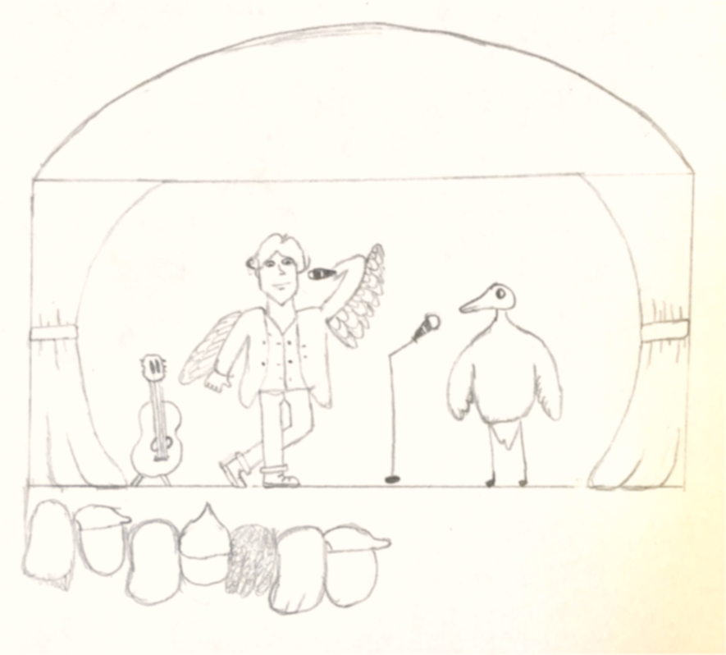
While they were relaxing, they saw a group of students from different countries (Latvia, Slovenia, Croatia and Spain) who were walking around. At first, their noise and voices frightened them a little, but soon they started to talk. The guys said they were in a Project called “Birds have to fly!” They were looking for some activity for that afternoon and the band had wanted to play in front of an audience for days. So… decided, the concert started.

They had real fun, Zvonko, Crane and the birds were great!
It was the beginning of a wonderful friendship.

