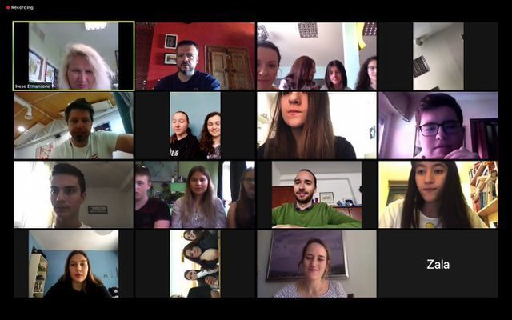

On Friday, the 25th of September, we had our second online meeting, this time only the teachers and coordinators from each school met. We talked about the situation in every country connected to the coronavirus. We discussed our project activities in the next few months, that we will carry out with our pupils. We agreed that at this moment is really hard to predict when we will manage to realize our mobilities. We concluded that we will try to do as many online activities that are possible and our project will be actualized.
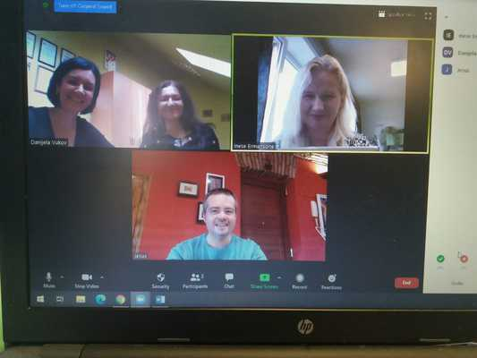

We had our first online meeting on Monday, the 8th of June, 2020. Our students, from all four schools, joined this meeting from their homes or schools. Students introduced themselves with a short presentation, told everyone something about themselves, and shared their expectations about our project. This was a nice way for students to get to know each other and realize that we all have similar problems with the pandemic and online schooling.

